Федеральное государственное автономное образовательное учреждение высшего образования

«Национальный исследовательский университет ИТМО»

Факультет программной инженерии и компьютерной техники

**Отчет по лабораторной работе №4**

**по дисциплине «Вычислительная математика»**

**Вариант 11**

**Выполнили**:

Студенты группы P3265

Кручинина Дарья Сергеевна

Москвитина Полина

**Преподаватель:**

Машина Екатерина Алексеевна

**Цели работы**

Найти функцию, являющуюся

наилучшим приближением заданной табличной функции по методу

наименьших квадратов.

**Порядок выполнения работы**

**Вычислительная реализация задачи**

Вычислительная часть лабораторной работы должна быть представлена

только в отчете.

Задание:

1. Сформировать таблицу табулирования заданной функции на

указанном интервале (см. табл. 1)

2. Построить линейное и квадратичное приближения по 11 точкам

заданного интервала;

3. Найти среднеквадратические отклонения для каждой

аппроксимирующей функции. Ответы дать с тремя знаками после

запятой;

4. Выбрать наилучшее приближение;

5. Построить графики заданной функции, а также полученные

линейное и квадратичное приближения;

6. Привести в отчете **подробные вычисления**.

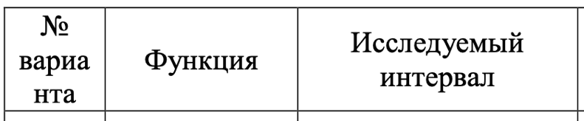

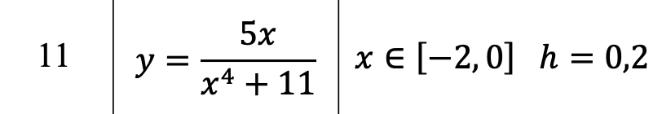

**Таблица табулирования:**

|  |  |  |  |  |  |  |  |  |  |  |  |
| --- | --- | --- | --- | --- | --- | --- | --- | --- | --- | --- | --- |
| Xi | -2 | -1.8 | -1.6 | -1.4 | -1.2 | -1.0 | -0.8 | -0.6 | -0.4 | -0.2 | 0 |
| Yi | -0.37 | -0.419 | -0.456 | -0.472 | -0.459 | -0.417 | -0.351 | -0.27 | -0.181 | -0.091 | 0 |

**Линейное приближение:**

$$f \left(x\right)=ax+b$$

Вычисляем суммы:

$$SX =\sum_{i=1}^{n}{x_{i}= -11}$$

$$SXX=\sum_{i=1}^{n}{x_{i}^{2}= 15,4}$$

$$SY =\sum_{i=1}^{n}{y_{i}= -3,486}$$

$$SXY =\sum_{i=1}^{n}{x_{i}y_{i}= 4,386}$$

Получаем систему линейных уравнений:

$$\left\{\begin{aligned}15,4a+\left(-11\right)b= 4,386 \\ \\ \left(-11\right)a+11b= -3,486\end{aligned}\right.$$

Из которой находим (правило Крамера):

a = 0,205

b = -0,112

Вычисляем значения аппроксимирующей функции $f \left(x\right)$:

$$f \left(x\right)=0,205x-0,0112$$

|  |  |  |  |  |  |  |  |  |  |  |  |
| --- | --- | --- | --- | --- | --- | --- | --- | --- | --- | --- | --- |
| Xi | -2 | -1.8 | -1.6 | -1.4 | -1.2 | -1.0 | -0.8 | -0.6 | -0.4 | -0.2 | 0 |
| Yi | -0.37 | -0.419 | -0.456 | -0.472 | -0.459 | -0.417 | -0.351 | -0.27 | -0.181 | -0.091 | 0 |
| $$f \left(x\right)$$ | -0.522 | -0.481 | -0.44 | -0.399 | -0.358 | -0.317 | -0.276 | -0.235 | -0.194 | -0.153 | -0.112 |
| Ei | -0.152 | -0.062 | 0.016 | 0.073 | 0.101 | 0.100 | 0.075 | 0.035 | -0.013 | -0.062 | -0.112 |

**Квадратичное приближение:**

$$f \left(x\right)=a+bx+cx^{2}$$

Вычисляем суммы:

$$\sum_{i=1}^{n}{x_{i}= -11}$$

$$\sum_{i=1}^{n}{x_{i}^{2}= 15,4}$$

$$\sum_{i=1}^{n}{x_{i}^{3}= -24,2}$$

$$\sum_{i=1}^{n}{x_{i}^{4}= 40,533}$$

$$\sum_{i=1}^{n}{y_{i}= -3,486}$$

$$\sum_{i=1}^{n}{x_{i}y_{i}= 4,386}$$

$$\sum_{i=1}^{n}{x_{i}^{2}y_{i}= -6,362}$$

Получили систему линейных уравнений, решив которую, определим значения

коэффициентов эмпирической формулы:

$$\left\{\begin{aligned}11a-11b+15,4c= -3,486 \\ -11a+15,4b-24,2c=4,386 \\ 15,4a-24,2b+40,533c= -6,362\end{aligned}\right.$$

Из которой находим:

a = 0,027

b = 0,668

c = 0,232

$$f \left(x\right)=0,027+0,668x+0,232x^{2}$$

|  |  |  |  |  |  |  |  |  |  |  |  |
| --- | --- | --- | --- | --- | --- | --- | --- | --- | --- | --- | --- |
| Xi | -2 | -1.8 | -1.6 | -1.4 | -1.2 | -1.0 | -0.8 | -0.6 | -0.4 | -0.2 | 0 |
| Yi | -0.37 | -0.419 | -0.456 | -0.472 | -0.459 | -0.417 | -0.351 | -0.27 | -0.181 | -0.091 | 0 |
| $$f \left(x\right)$$ | -0.383 | -0.425 | -0.449 | -0.454 | -0.441 | -0.409 | -0.359 | -0.291 | -0.203 | -0.098 | -0.026 |
| Ei | -0.013 | -0.006 | 0.007 | 0.018 | 0.018 | 0.008 | -0.008 | -0.021 | -0.022 | -0.007 | -0.026 |

**Среднеквадратические отклонения:**

$δ$ (отклонение линейного приближения) $= \sqrt{\frac{\sum_{i=1}^{n}{E_{i}^{2}}}{n}}≈0,083$

$δ$ (отклонение квадратичного приближения) $= \sqrt{\frac{\sum_{i=1}^{n}{E_{i}^{2}}}{n}}≈0,016$

Наилучшим приближением является квадратичное, так как оно меньше

Графики:

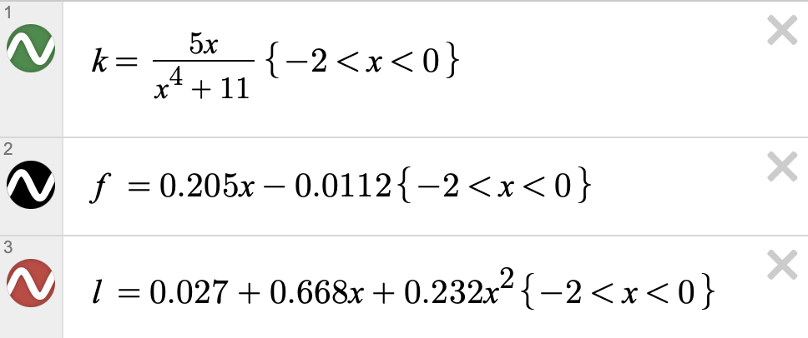

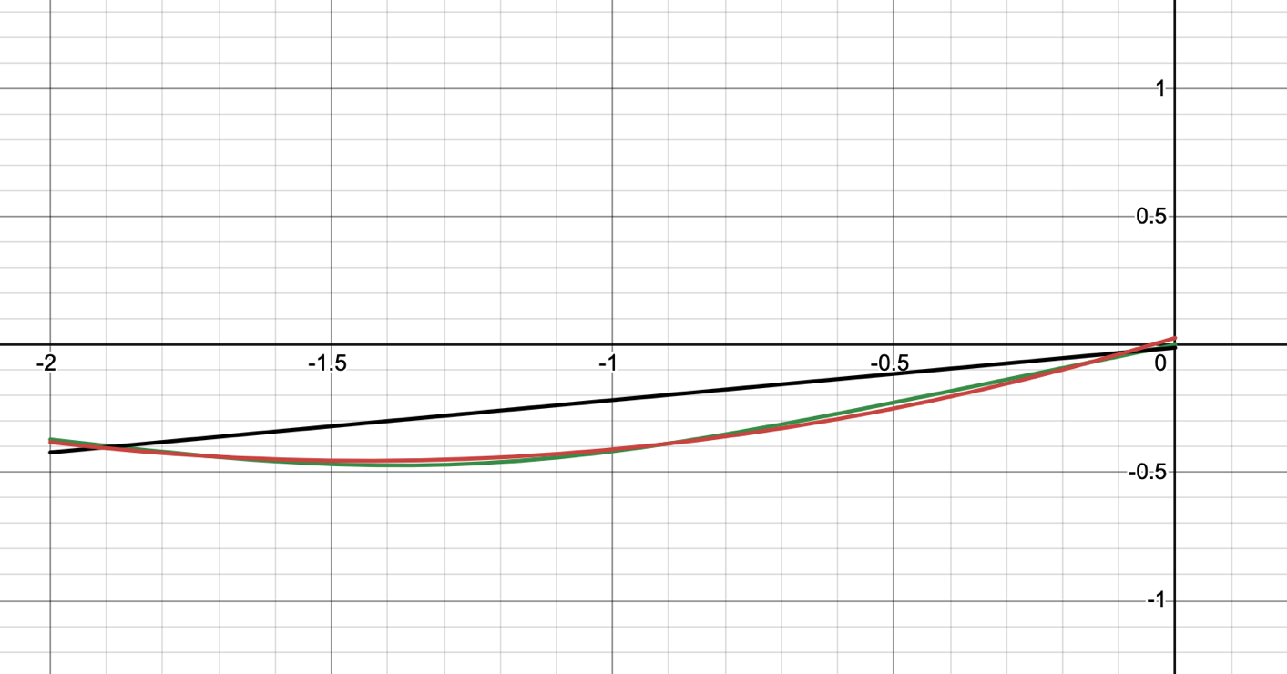

**Программная реализация задачи**

**Для исследования использовать:**

линейную функцию,

полиномиальную функцию 2-й степени,

полиномиальную функцию 3-й степени,

экспоненциальную функцию,

логарифмическую функцию,

степенную функцию.

**from** __future__ **import** annotations

**import** math

**import** os

**from** parser **import** Parser

**from** dto **import** PointTable, ApproxRes

**from** approx **import** APPROXIMATORS

**from** utils **import** draw_graph

**def** main() -> **None**:

os.chdir('/' + '/'.join(__file__.split('/')[:-2]) + '/resources')

data: PointTable | **None** = Parser.parse_table_from_file(input('Type input filename -> '))

**if** data **is** **None**:

**return**

Parser.clear_file()

min_sko: float = math.inf

min_type: str | **None** = **None**

**for** approximator **in** APPROXIMATORS:

res: ApproxRes = approximator(data)

Parser.print_res(res)

**if** res.data **is** **not** **None**:

draw_graph(res.data, res.type)

**if** res.data.sko < min_sko:

min_sko = res.data.sko

min_type = res.type

**if** min_type **is** **not** **None**:

print(f'Best approximator is {min_type} with sko = {min_sko:.4g}')

**if** __name__ == '__main__':

main()

**import** math

**from** dto **import** *

**from** utils **import** avg

**from** enum **import** Enum

**from** slau_solver.matrix **import** Equation

**def** calc_pirson_kf(def_data: DataTable) -> float:

x_list: list[float] = def_data.x_list

y_list: list[float] = def_data.y_list

n: int = len(x_list)

avg_x = avg(x_list)

avg_y = avg(y_list)

**return** (sum([(x_list[i] - avg_x) * (y_list[i] - avg_y) **for** i **in** range(n)]) /

math.sqrt(sum([(x_list[i] - avg_x) ** 2 **for** i **in** range(n)]) *

sum([(y_list[i] - avg_y) ** 2 **for** i **in** range(n)])

))

**def** calc_det_kf(def_data: DataTable) -> float:

phi_list: list[float] = def_data.phi_x

y_list: list[float] = def_data.y_list

n: int = len(phi_list)

avg_phi = avg(phi_list)

**return** (1 - sum([(y_list[i] - phi_list[i]) ** 2 **for** i **in** range(n)]) /

sum([(y_list[i] - avg_phi) ** 2 **for** i **in** range(n)]))

**def** calc_sko(eps: list[float]) -> float:

n: int = len(eps)

**return** math.sqrt(sum([eps[i] ** 2 **for** i **in** range(n)]) / n)

**def** get_def_data(points: PointTable, func: callable) -> DataTable:

x_list = points.get_all_x()

y_list = points.get_all_y()

phi_x = [func(x) **for** x **in** x_list]

eps = [phi_x[i] - y_list[i] **for** i **in** range(points.n)]

**return** DataTable(x_list, y_list, phi_x, eps)

**def** calc_linear_kfs(points: PointTable) -> tuple[float, float]:

sx, sy, sxx, sxy, n = (points.sx(), points.sy(),

points.sxx(), points.sxy(), points.n)

eq: Equation = Equation.create([

[sxx, sx],

[sx, n],

[sxy, sy]

])

eq.solve()

a, b = eq.answers.elems

**return** a, b

**def** approx_linear(points: PointTable) -> ApproxRes:

a, b = calc_linear_kfs(points)

callback: callable = **lambda** x: a * x + b

func_view: str = f'{a:.3g}x'

**if** b > 0:

func_view += f' + {b:.3g}'

**elif** b < 0:

func_view += f' - {-b:.3g}x'

def_data: DataTable = get_def_data(points, callback)

**return** ApproxRes(

type='Линейная аппроксимация',

data=LinearApproxData(

func_view=func_view,

callback=callback,

sko=calc_sko(def_data.eps),

x_list=def_data.x_list,

y_list=def_data.y_list,

phi_x=def_data.phi_x,

eps=def_data.eps,

pirson_kf=calc_pirson_kf(def_data),

det_kf=calc_det_kf(def_data)

),

error_message=**None**

)

**def** approx_quad(points: PointTable) -> ApproxRes:

sx, sxx, s3x, s4x, sy, sxy, sxxy, n = \

(points.sx(), points.sxx(), points.s3x(), points.s4x(),

points.sy(), points.sxy(), points.sxxy(), points.n)

eq: Equation = Equation.create([

[s4x, s3x, sxx],

[s3x, sxx, sx],

[sxx, sx, n],

[sxxy, sxy, sy]

])

eq.solve()

a, b, c = eq.answers.elems

callback: callable = **lambda** x: a * x * x + b * x + c

func_view: str = f'{a:.3g}x^2'

**if** b > 0:

func_view += f' + {b:.3g}x'

**elif** b < 0:

func_view += f' - {-b:.3g}x'

**if** c > 0:

func_view += f' + {c:.3g}'

**elif** c < 0:

func_view += f' - {-c:.3g}'

def_data: DataTable = get_def_data(points, callback)

**return** ApproxRes(

type='Квадратичная аппроксимация',

data=ApproxData(

func_view=func_view,

callback=callback,

sko=calc_sko(def_data.eps),

x_list=def_data.x_list,

y_list=def_data.y_list,

phi_x=def_data.phi_x,

eps=def_data.eps,

det_kf=calc_det_kf(def_data)

),

error_message=**None**

)

**def** approx_cube(points: PointTable) -> ApproxRes:

sx, sxx, s3x, s4x, s5x, s6x, sy, sxy, sxxy, s3xy, n = \

(points.sx(), points.sxx(), points.s3x(), points.s4x(),

points.s5x(), points.s6x(), points.sy(), points.sxy(),

points.sxxy(), points.s3xy(), points.n)

eq: Equation = Equation.create([

[s6x, s5x, s4x, s3x],

[s5x, s4x, s3x, sxx],

[s4x, s3x, sxx, sx],

[s3x, sxx, sx, n],

[s3xy, sxxy, sxy, sy]

])

eq.solve()

a, b, c, d = eq.answers.elems

callback: callable = **lambda** x: a * (x ** 3) + b * (x ** 2) + c * x + d

func_view: str = f'{a:.3g}x^3'

**if** b > 0:

func_view += f' + {b:.3g}x^2'

**elif** b < 0:

func_view += f' - {-b:.3g}x^2'

**if** c > 0:

func_view += f' + {c:.3g}x'

**elif** c < 0:

func_view += f' - {-c:.3g}x'

**if** d > 0:

func_view += f' + {d:.3g}'

**elif** d < 0:

func_view += f' - {-d:.3g}'

def_data: DataTable = get_def_data(points, callback)

**return** ApproxRes(

type='Кубическая аппроксимация',

data=ApproxData(

func_view=func_view,

callback=callback,

sko=calc_sko(def_data.eps),

x_list=def_data.x_list,

y_list=def_data.y_list,

phi_x=def_data.phi_x,

eps=def_data.eps,

det_kf=calc_det_kf(def_data)

),

error_message=**None**

)

**def** approx_exp(points: PointTable) -> ApproxRes:

**if** **not** points.log_y_is_safe():

**return** ApproxRes(

type='Экспоненциальная аппроксимация',

data=**None**,

error_message="Can't approximate with negative ordinates"

)

points_copy: PointTable = points.copy()

**for** i **in** range(points.n):

points_copy[i].y = math.log(points_copy[i].y)

b, A = calc_linear_kfs(points_copy)

a = math.exp(A)

callback: callable = **lambda** x: a * math.exp(b * x)

func_view: str = f'{a:.3g}e^({b:.3g}x)'

def_data: DataTable = get_def_data(points, callback)

**return** ApproxRes(

type='Экспоненциальная аппроксимация',

data=ApproxData(

func_view=func_view,

callback=callback,

sko=calc_sko(def_data.eps),

x_list=def_data.x_list,

y_list=def_data.y_list,

phi_x=def_data.phi_x,

eps=def_data.eps,

det_kf=calc_det_kf(def_data)

),

error_message=**None**

)

**def** approx_log(points: PointTable) -> ApproxRes:

**if** **not** points.log_x_is_safe():

**return** ApproxRes(

type='Логарифмическая аппроксимация',

data=**None**,

error_message="Can't approximate with negative abscisses"

)

points_copy: PointTable = points.copy()

**for** i **in** range(points.n):

points_copy[i].x = math.log(points_copy[i].x)

a, b = calc_linear_kfs(points_copy)

callback: callable = **lambda** x: a * math.log(x) + b

func_view: str = f'{a:.3g}ln(x)'

**if** b > 0:

func_view += f' + {b:.3g}'

**elif** b < 0:

func_view += f' - {-b:.3g}'

def_data: DataTable = get_def_data(points, callback)

**return** ApproxRes(

type='Логарифмическая аппроксимация',

data=ApproxData(

func_view=func_view,

callback=callback,

sko=calc_sko(def_data.eps),

x_list=def_data.x_list,

y_list=def_data.y_list,

phi_x=def_data.phi_x,

eps=def_data.eps,

det_kf=calc_det_kf(def_data)

),

error_message=**None**

)

**def** approx_step(points: PointTable) -> ApproxRes:

**if** **not** points.log_x_is_safe() **or** **not** points.log_y_is_safe():

**return** ApproxRes(

type='Степпеная аппроксимация',

data=**None**,

error_message="Can't approximate with negative abscisses or negative ordinates"

)

points_copy: PointTable = points.copy()

**for** i **in** range(points.n):

points_copy[i].x = math.log(points_copy[i].x)

points_copy[i].y = math.log(points_copy[i].y)

b, A = calc_linear_kfs(points_copy)

a = math.exp(A)

callback: callable = **lambda** x: a * (x ** b)

func_view: str = f'{a:.3g}x^({b:.3g})'

def_data: DataTable = get_def_data(points, callback)

**return** ApproxRes(

type='Степпеная аппроксимация',

data=ApproxData(

func_view=func_view,

callback=callback,

sko=calc_sko(def_data.eps),

x_list=def_data.x_list,

y_list=def_data.y_list,

phi_x=def_data.phi_x,

eps=def_data.eps,

det_kf=calc_det_kf(def_data)

),

error_message=**None**

)

APPROXIMATORS: list[callable] = [

approx_linear,

approx_quad,

approx_cube,

approx_exp,

approx_log,

approx_step

]

**from** __future__ **import** annotations

**from** dataclasses **import** dataclass

**import** pylab **as** p

@dataclass

**class** Point:

x: float

y: float

**def** __str__(self) -> str:

**return** f'({self.x}, {self.y})'

**def** copy(self) -> Point:

**return** Point(self.x, self.y)

**class** PointTable:

**def** __init__(self, points: list[Point]) -> **None**:

self.points = sorted(points, key=**lambda** point: point.x)

self.n = len(self.points)

**def** copy(self) -> PointTable:

**return** PointTable([point.copy() **for** point **in** self.points])

**def** __getitem__(self, index: int) -> Point:

**return** self.points[index]

**def** __setitem__(self, index: int, point: Point) -> **None**:

self.points[index] = point

**def** log_y_is_safe(self) -> bool:

**for** point **in** self.points:

**if** point.y <= 0 **or** point.y == 1:

**return** **False**

**return** **True**

**def** log_x_is_safe(self) -> bool:

**for** point **in** self.points:

**if** point.x <= 0 **or** point.x == 1:

**return** **False**

**return** **True**

**def** get_all_x(self) -> list[float]:

**return** [point.x **for** point **in** self.points]

**def** get_all_y(self) -> list[float]:

**return** [point.y **for** point **in** self.points]

**def** sx(self) -> float:

**return** sum([point.x **for** point **in** self.points])

**def** sxx(self) -> float:

**return** sum([point.x ** 2 **for** point **in** self.points])

**def** s3x(self) -> float:

**return** sum([point.x ** 3 **for** point **in** self.points])

**def** s4x(self) -> float:

**return** sum([point.x ** 4 **for** point **in** self.points])

**def** s5x(self) -> float:

**return** sum([point.x ** 5 **for** point **in** self.points])

**def** s6x(self) -> float:

**return** sum([point.x ** 6 **for** point **in** self.points])

**def** sy(self) -> float:

**return** sum([point.y **for** point **in** self.points])

**def** sxy(self) -> float:

**return** sum([point.x * point.y **for** point **in** self.points])

**def** sxxy(self) -> float:

**return** sum([point.x * point.x * point.y **for** point **in** self.points])

**def** s3xy(self) -> float:

**return** sum([(point.x ** 3) * point.y **for** point **in** self.points])

@dataclass

**class** DataTable:

x_list: list[float]

y_list: list[float]

phi_x: list[float]

eps: list[float]

@dataclass

**class** ApproxData:

func_view: str

callback: callable

sko: float

x_list: list[float]

y_list: list[float]

phi_x: list[float]

eps: list[float]

det_kf: float

**def** __str__(self) -> str:

**return** (f"phi: {self.func_view}\n" +

f"sko: {self.sko:.3g}\n" +

f"det_kf: {self.det_kf:.3g}\n\n")

@dataclass

**class** LinearApproxData(ApproxData):

pirson_kf: float

**def** __str__(self) -> str:

**return** f'{super().__str__()[:-1]}pirson: {self.pirson_kf:.3g}\n\n'

@dataclass

**class** ApproxRes:

type: str

data: ApproxData | **None**

error_message: str | **None**

**def** __str__(self) -> str:

prefix = f'-- {self.type}\n'

**if** self.error_message **is** **not** **None**:

**return** f'{prefix}\tERROR: {self.error_message}\n\n'

**else**:

**return** f'{prefix}{self.data}'

**from** __future__ **import** annotations

**from** dto **import** PointTable, Point, ApproxRes

**from** utils **import** to_float

DEFAULT_FILE_IN = 'test'

DEFAULT_FILE_OUT = 'output'

**class** Parser:

@staticmethod

**def** parse_table_from_file(filename: str) -> PointTable | **None**:

**if** filename **is** **None** **or** filename == '':

filename = DEFAULT_FILE_IN

**try**:

x_line: list[float]

y_line: list[float]

**with** open(filename, 'r') **as** f:

x_line = list(map(to_float, f.readline().strip().split(' ')))

y_line = list(map(to_float, f.readline().strip().split(' ')))

**if** len(x_line) != len(y_line):

print('Length of X and Y are not equals')

**return** **None**

**if** len(x_line) < 8 **or** len(x_line) > 12:

print('Number of points should be between 8 and 12')

**return** **None**

points: list[Point] = []

**for** i **in** range(len(x_line)):

points.append(Point(x_line[i], y_line[i]))

**return** PointTable(points)

**except** (IOError, ValueError):

print('File not exist or invalid')

@staticmethod

**def** print_res(res: ApproxRes, filename: str = **None**) -> **None**:

**if** filename **is** **None** **or** filename == '':

filename = DEFAULT_FILE_OUT

**with** open(filename, 'a') **as** file:

file.write(str(res))

@staticmethod

**def** clear_file(filename: str = **None**) -> **None**:

**if** filename **is** **None** **or** filename == '':

filename = DEFAULT_FILE_OUT

**with** open(filename, 'w'):

**pass**

**from** matplotlib.axes **import** Axes

**from** dto **import** *

**import** matplotlib.pyplot **as** plt

**def** to_float(val: str) -> float:

**return** float(val.replace(',', '.'))

**def** avg(data: list[float]) -> float:

**return** sum(data) / len(data)

**def** draw_graph(data: ApproxData, title: str) -> **None**:

ax: Axes = plt.gca()

ax.spines['left'].set_position('zero')

ax.spines['bottom'].set_position('zero')

ax.spines['right'].set_color('none')

ax.spines['top'].set_color('none')

ax.set_aspect('equal', adjustable='box')

plt.plot(data.x_list, data.y_list, 'ro', linewidth=3)

plt.plot(data.x_list, data.phi_x, linewidth=1, label=data.func_view)

plt.grid(**True**)

plt.legend()

plt.title(title)

plt.show()

**from** __future__ **import** annotations

**from** typing **import** List

**import** random

**from** utils **import** to_float

**class** Vector:

elems: List[float] = **None**

**def** __init__(self, elems_or_size: int | List[float]) -> **None**:

**if** isinstance(elems_or_size, List):

self.elems = elems_or_size

**else**:

self.elems = [0 **for** _ **in** range(elems_or_size)]

**def** size(self):

**return** len(self.elems)

**def** copy(self) -> Vector:

**return** Vector(self.elems[:])

**def** __getitem__(self, index: int | slice) -> float | Vector:

**if** isinstance(index, slice):

**return** Vector(self.elems[index])

**else**:

**return** self.elems[index]

**def** __setitem__(self, key: int, value: float) -> **None**:

self.elems[key] = value

**def** swap_elems(self, index1: int, index2: int) -> **None**:

self[index1], self[index2] = self[index2], self[index1]

**def** has_only_zeros(self) -> bool:

**return** max(self.elems) == 0 **and** min(self.elems) == 0

**def** __mul__(self, num_or_vector: float | Vector) -> Vector:

new_vec: Vector = Vector(self.size())

**for** i **in** range(self.size()):

**if** isinstance(num_or_vector, float):

new_vec[i] = self[i] * num_or_vector

**else**:

new_vec[i] = self[i] * num_or_vector[i]

**return** new_vec

**def** sum(self) -> float:

**return** sum(self.elems)

**def** __add__(self, other) -> Vector:

new_vec: List[float] = [0 **for** _ **in** range(self.size())]

**for** i **in** range(self.size()):

new_vec[i] = self[i] + other[i]

**return** Vector(new_vec)

**class** Matrix:

elems: List[Vector] = **None**

**def** __init__(self, elems_or_size: List[Vector] | int) -> **None**:

**if** isinstance(elems_or_size, int):

self.elems = [Vector(elems_or_size) **for** _ **in** range(elems_or_size)]

**else**:

self.elems = elems_or_size

**def** __getitem__(self, index: int) -> Vector:

**return** self.elems[index]

**def** __setitem__(self, key: int, row: Vector) -> **None**:

self.elems[key] = row

**def** swap_rows(self, index1: int, index2: int) -> **None**:

self[index1], self[index2] = self[index2], self[index1]

**def** size(self) -> int:

**return** len(self.elems)

**def** copy(self) -> Matrix:

**return** Matrix([row.copy() **for** row **in** self.elems])

**def** is_correct(self) -> bool:

**for** row **in** self.elems:

**if** row.has_only_zeros():

**return** **False**

**for** i **in** range(self.size()):

col_has_non_zero: bool = **False**

**for** j **in** range(self.size()):

**if** self[j][i] != 0:

col_has_non_zero = **True**

**if** **not** col_has_non_zero:

**return** **False**

**return** **True**

**class** Equation:

matrix: Matrix = **None**

b_vector: Vector = **None**

det: float = **None**

triangled: Equation = **None**

answers: Vector = **None**

residuals: Vector = **None**

**def** __init__(self, matrix: Matrix, b_vector: Vector) -> **None**:

self.matrix = matrix

self.b_vector = b_vector

@staticmethod

**def** create(data: list[list[float]]) -> Equation | **None**:

size: int = len(data) - 1

**for** row **in** data:

**if** len(row) != size:

print('Invalid data in Equation.create')

**return** **None**

matrix: Matrix = Matrix(size)

b_vector: Vector = Vector(data[-1])

**for** i **in** range(size):

row: Vector = Vector(data[i])

matrix[i] = row

**return** Equation(matrix, b_vector)

**def** copy(self) -> Equation:

**return** Equation(self.matrix.copy(), self.b_vector.copy())

**def** size(self) -> int:

**return** self.b_vector.size()

# Приведение к треугольному виду

**def** triangle(self) -> **None**:

perm_count = 0

triangled_eq: Equation = self.copy()

**for** i **in** range(triangled_eq.size() - 1):

# Выбор главного элемента

max_row_idx: int = i

**for** j **in** range(i, triangled_eq.size()):

**if** abs(triangled_eq.matrix[j][i]) > abs(triangled_eq.matrix[max_row_idx][i]):

max_row_idx = j

# Перестановка строк

**if** max_row_idx != i:

triangled_eq.matrix.swap_rows(i, max_row_idx)

triangled_eq.b_vector.swap_elems(i, max_row_idx)

perm_count += 1

# Убираем x[i][i] из каждой строки ниже i

**for** j **in** range(i + 1, triangled_eq.size()):

kf: float = - triangled_eq.matrix[j][i] / triangled_eq.matrix[i][i]

adding_vec = triangled_eq.matrix[i] * kf

triangled_eq.matrix[j] += adding_vec

adding_b = kf * triangled_eq.b_vector[i]

triangled_eq.b_vector[j] += adding_b

self.triangled: Equation = triangled_eq

self.set_det(perm_count)

# Считает детерминант треугольной матрицы

**def** set_det(self, k: int) -> **None**:

self.det: float = 1

**for** i **in** range(self.size()):

self.det *= self.triangled.matrix[i][i]

self.det *= ((-1) ** k)

# Решает уравнение, считает вектор ответов

**def** calc_answers(self) -> **None**:

**if** **not** self.matrix.is_correct():

**return**

self.triangle()

**if** self.det == 0:

**return**

answers: Vector = Vector(self.size())

**for** i **in** range(self.size() - 1, -1, -1):

answer = self.triangled.b_vector[i]

**for** j **in** range(self.size() - 1, i, -1):

answer -= self.triangled.matrix[i][j] * answers[j]

answers[i] = answer / self.triangled.matrix[i][i]

self.answers = answers

**def** solve(self) -> **None**:

self.calc_answers()

**if** self.answers **is** **None**:

print('Invalid matrix! No answers or any answer')